**LAB # 7**



**CSE-203L Circuit & Systems-II Lab**

**Fall 2022**

**Submitted by: Ali Asghar**

**Registration No.: 21PWCSE2059**

**Class Section: C**

“On my honor, as student of University of Engineering and Technology, I have neither given nor received unauthorized assistance on this academic work.”

Student Signature: ______________

Submitted to:

**Engr. Faiz Ullah**

6th December, 2022

Department of Computer Systems Engineering

University of Engineering and Technology, Peshawar

**TITLE:**

**Operational Amplifiers**

**Basic Characteristics and Applications**

**OBJECTIVES:**

* To learn how to use the operational amplifier (op-amp).
* To learn some of its applications like the Inverting amplifier, non-inverting amplifier.

**APPARATUS:**

* Oscilloscope
* AC Function Generator

**COMPONENTS:**

* 10k Ω Resistor
* 100k Ω Resistor
* 741 Op-Amp

**THEORY OVERVIEW:**

The Operational Amplifier (Op Amp) is an extremely useful device, as we will see in this lab. With the addition of a few external components, an extraordinary variety of functions can be implemented. The Op Amp is an active element that needs to be supplied with power to operate. A common way to supply this power is shown in Figure 1(a). Two power supply voltages are used, with equal values denoted by Vcc and VDD (or ±VCC) (often in the range of 5 V to15 V). The common node between the supplies is the ground node. The op amp’s output voltage is taken between the output terminal and the ground node. The remaining two terminals are the input of the op amp. An interesting property of the op-amp is that the output voltage is only a function of the difference of the two input Terminals. Figure 1(b) shows the top view of widely used Op Amp type known as the 741. It comes in a package, with metal pins.

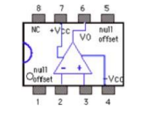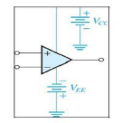

**Figure 1 (a) and (b)**

The most basic function of the op amp is the voltage amplification. However, the output voltage of a real op amp is limited to the range between certain limits that depend on the internal design of the op amp. As shown in Figure 2, when the output voltage tries to exceed these limits, clipping occurs.

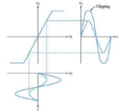

**Figure 2**.

**PROCEDURE:**

**Inverting AMPLIFIER**

1. Make the circuit for Inverting Amplifier with Rf = 100 kΩ and Rin= 10kΩ (gain 10).
2. For five or more values of Vin, in the range ±0.7V calculate the value of Vout using the following formula for voltage gain of Inverting amplifier and write them in below Table.
3. *Av=Vout /Vin= -Rf / Rin.*
4. Measure the value of Vout for each value of Vin as mentioned above. Find the % age error.
5. Set the Function generator at a frequency of 1 kHz and apply as input Vin to the inverting amplifier. Use the two channels of the scope to monitor the inverting input Vin of the op-amp and the output Vout. Slowly increase the amplitude of the input signal, starting near zero. Observe the phase difference between the input and output. Keeping the amplitude of the input low and constant, vary its frequency. Observe the reduction in output amplitude as frequency increases.
6. Repeat for DC Supply.

**NON-Inverting AMPLIFIER**

1. Set up the non-inverting amplifier circuit of Figure 4 with R1 = 10 k. With a 1 kHz sinusoidal input having different amplitudes, calculate the output with R2 = 100k and with R2= 10k using the
2. formula and write the results in front of each input in Table below :
3. *Av =Vout/Vin=1+R2/R1*
4. Measure the output with an oscilloscope and write them in front of each input in the table. Find the % age error.
5. Repeat for DC supply.

**OBSERVATIONS:**

1. **For AC Source**

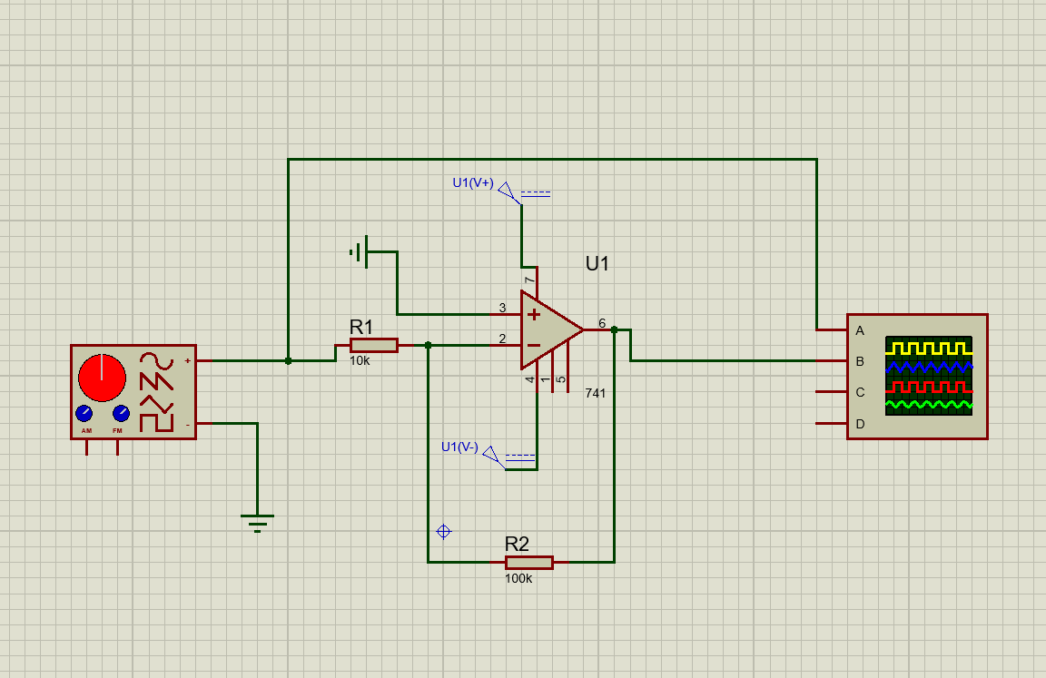

Inverting Amplifier

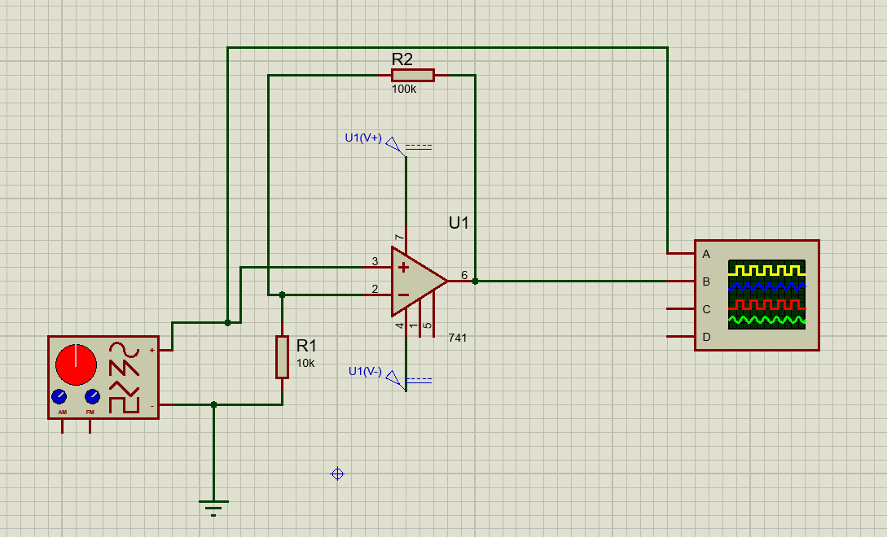

Non-Inverting Amplifier

**Table 1(Inverting Amp)**

|  |  |  |  |
| --- | --- | --- | --- |
| Vin | Calculated Vout | Measured Vout | %Deviation |
| 0.50V | -5.0 V | -5.00 V | 0 % |
| 0.65 V | -6.5 V | -6.40 V | 1.5 % |
| 0.20 V | -2.0 V | -2.00 V | 0 % |
| 0.30 V | -3.0 V | -3.00 V | 0 % |
| 0.10 V | -1.0 V | -1.00 V | 0 % |

**Table 2(Non-Inverting Amp)**

|  |  |  |  |
| --- | --- | --- | --- |
| Vin | Calculated Vout | Measured Vout | %Deviation |
| 0.50V | 5.5 V | 5 divisions x 1.1 = 5.5 V | 0 % |
| 0.65 V | 7.15 V | 6.5 divisions x 1.1 = 7.15 V | 0 % |
| 0.20 V | 2.2 V | 2 divisions x 1.1 = 2.2 V | 0 % |
| 0.30 V | 3.3 V | 3 divisions x 1.1 = 3.3 V | 0 % |
| 0.10 V | 1.1 V | 1 divisions x 1.1 = 1.1 V | 0 % |

1. **For DC Source**

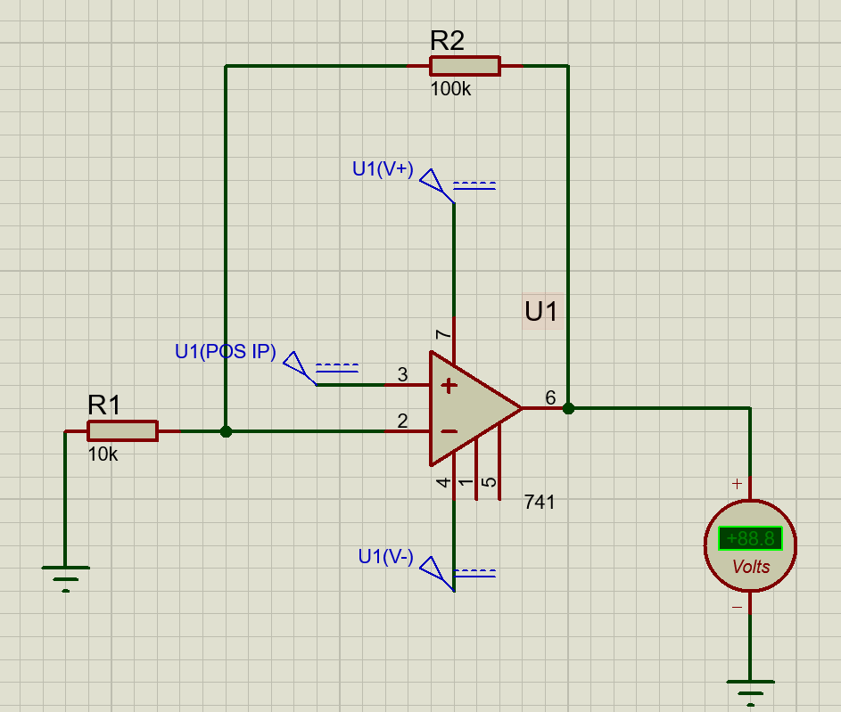

Non-Inverting Amplifier

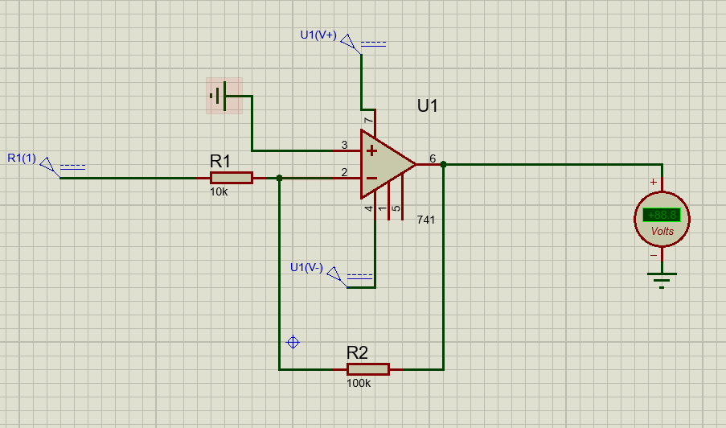

Inverting Amplifier

**Table 3(Non-Inverting Amp)**

|  |  |  |  |
| --- | --- | --- | --- |
| Vin | Calculated Vout | Measured Vout | %Deviation |
| 0.50V | -5.5 V | -5.52 V | 0.36 % |
| 0.65 V | -7.15 V | -7.17 V | 0.28 % |
| 0.20 V | -2.2 V | -2.22 V | 0.90 % |
| 0.30 V | -3.3 V | -3.32 V | 0.60 % |
| 0.10 V | -1.1 V | -1.12 V | 1.81 % |

**Table 4(Inverting Amp)**

|  |  |  |  |
| --- | --- | --- | --- |
| Vin | Calculated Vout | Measured Vout | %Deviation |
| 0.50V | -5.0 V | -4.98 V | 0.40 % |
| 0.65 V | -6.5 V | 6.48 V | 0.31 % |
| 0.20 V | -2.0 V | -1.98 V | 1.00 % |
| 0.30 V | -3.0 V | -2.98 V | 0.60 % |
| 0.10 V | -1.0 V | -1.00 V | 2.00 % |

**CONCLUSION:**

We conclude the following results from this experiment:

* Operational Amplifier amplifies a signal by some gain value
* Operational Amplifier can perform different functions in different circuit configurations
* Operational Amplifier can invert a signal when used as an Inverting Amplifier or it can amplify a signal without inverting it; when used as a Non-Inverting Amplifier
* The value of gain k of an Inverting/Non-Inverting Op-Amp depends upon the value of R1(connected btw input and inverting terminal) and Rf (known as feedback resistor; connected btw output and inverting terminal)